**User Test “Build a Performance”**

In order to ensure that the “Build a Performance” form is working we have a standard validation test across all forms

1. User must navigate to site: <http://vivifievents.com/>
2. User must click on the navigation bar and direct to “Browse” and then click “Build a Performance”

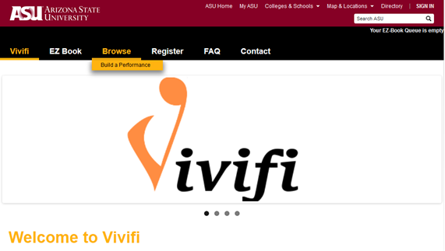

(Screenshot of main page)

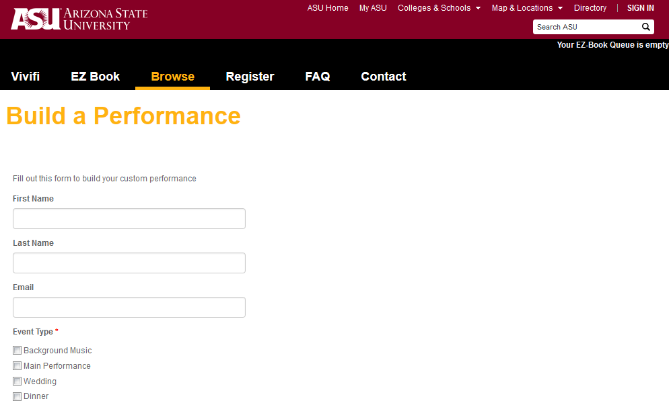

(Unfilled “Build a Performance” form)

1. User must then fill in all required fields (TO ADD RIGHT HERE)

First name, last name, and email are NOT required and should be required; the only required entry at this point in time is “Event Type” and this will likely need to be modified before final release.

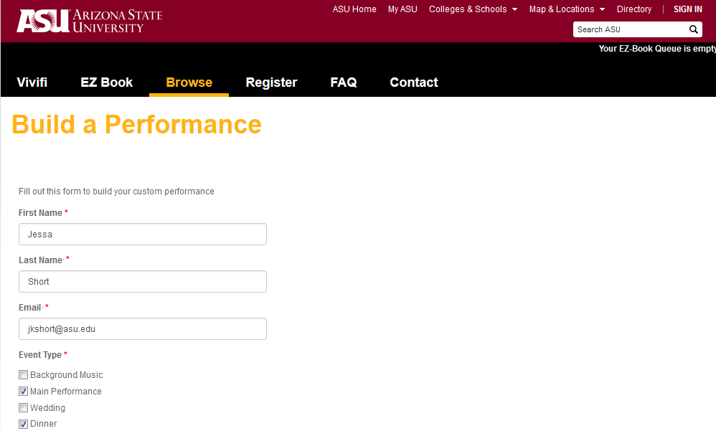

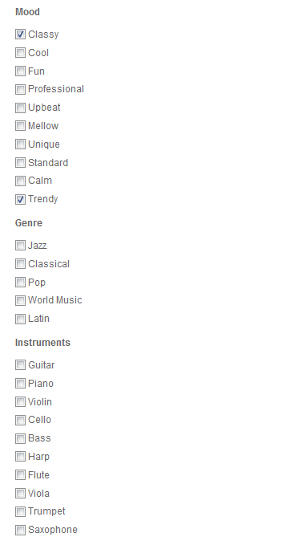



From there they will click to the button “Submit”

1. Once the user submits this (fills out completely and hits submit), it will redirect to display a message to the user that an email has been sent to the Vivifi site administrator.

